***Dynamic Signal Data for Time Slot (hours) wise.***

**Step-1:** Select Date, Start Hour & End Hour **(based on the selected time zone can see the Out Put**). Based on the selected Date Start hour & End Hour Zone will change.

**(Search Criteria look like below screen)**

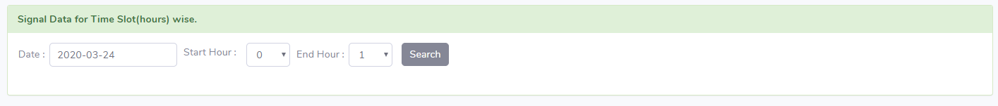

**Step-2**:Date (2020-03-08) & Time Slot (0 - 1), **(Output will come like below screen).**

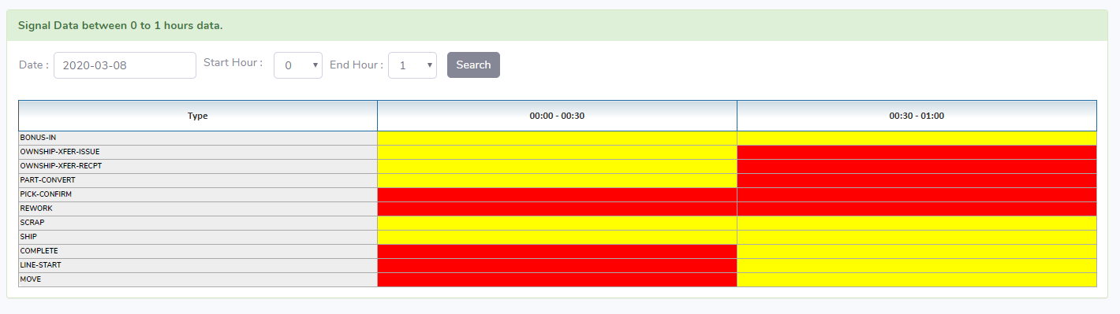

**Step-3:** Date (2020-03-08) & Time Slot (0 - 14),(**Output will come like below screen).**

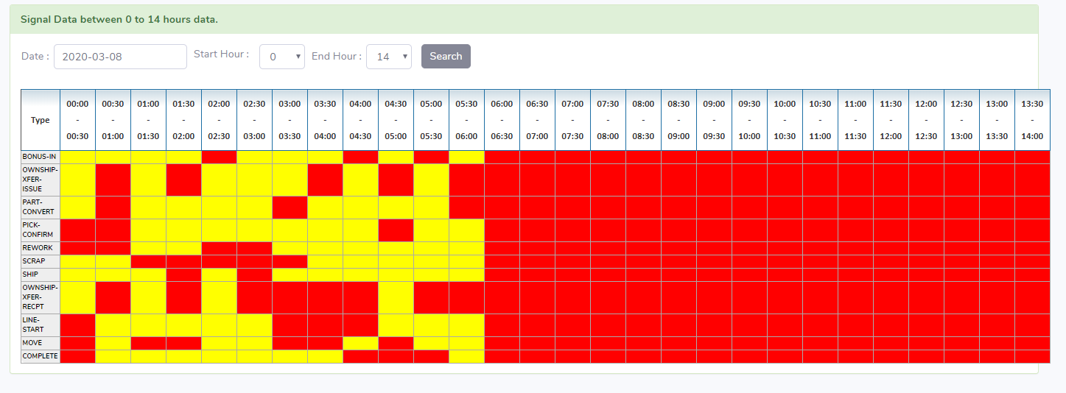

**Step-4**:Date (2020-03-08) & Time Slot (21 - 24) (**Output will come like below screen).**

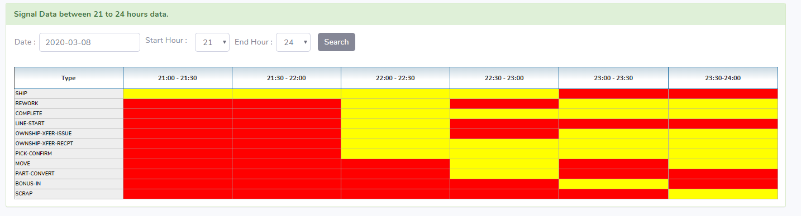

***Code Explanation***

**Step-5:** Bind the Dropdown list(s) and update the dropdown list(s) automatically based on the search criteria & Passing the Date, Time Slot (Start hour & End hour) to BLL (Method), get the Dynamic Data, based on the data apply the colors at UI side (1- Yellow & 0-Red).

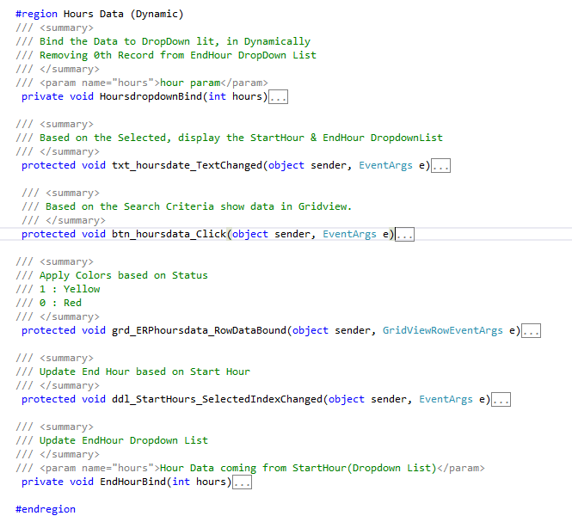

**Step-6:** Based on the GetHoursSignelData() with Paramus, call the DAL .cs file for Data from Database.

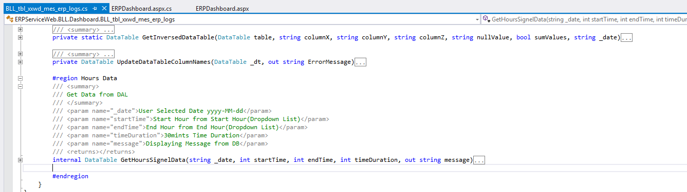

**Step-7:** Based on the ***GetHoursSignelData()***, call the Database using stored procedure & store the data in Data set.

